***Wooden game spinning lollipop***

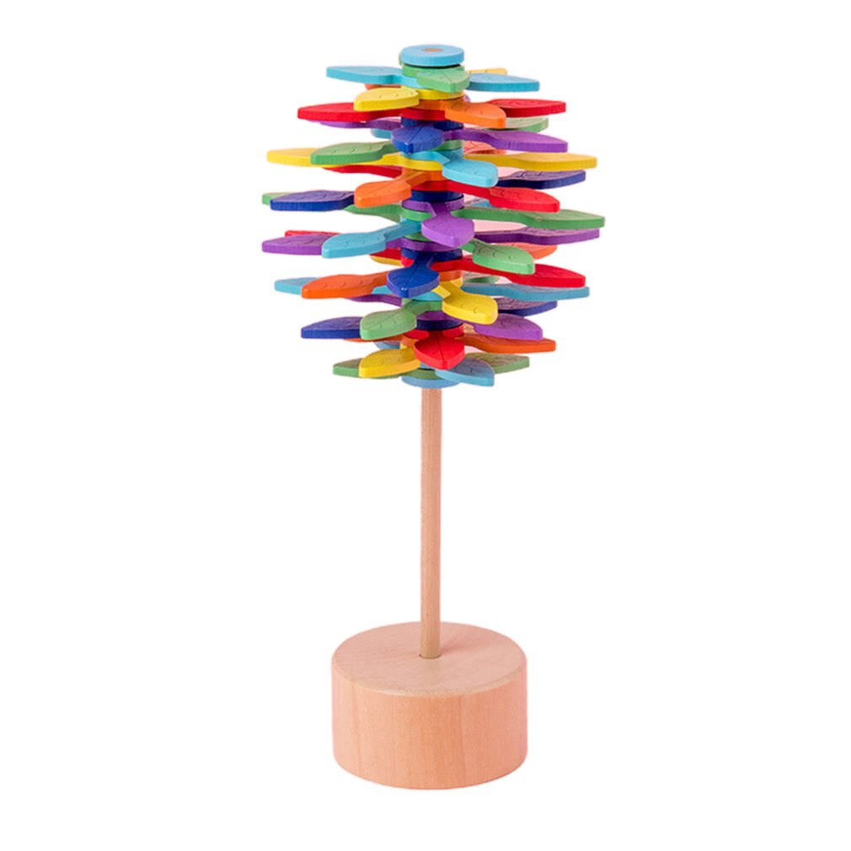

*The lollipop spinning game is made from natural wood. There are many colors for you to choose from. You can note the color you want to get when ordering. This is a very interesting game*